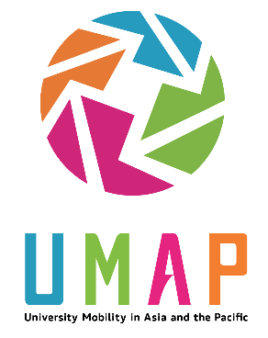 | University Mobility in Asia and the Pacific (UMAP)  COIL – Honours Program 2021  For additional information or support, please email umap-is@umap.org

Completed application and additional documents must be submitted to the UMAP International Secretariat at umap-is@umap.org by July 1, 2021 (PDT)

Student Applicant Information
Full Name:
 | First |  | Family

Email
Home Institution Name
 | e.g. University of the Sea

Location of Home Institution
 | City | Country

Home Institution Contact Person and Email
 | Name Anna Hsu | Email yuanru616@nuk.edu.tw

Have you previously participated in UMAP programs? | YES | NO | Have you previously participated in any international education program? | YES | NO

Education
Please include an up-to-date (must be dated 2021) unofficial transcript in your application. It is acceptable to take a screenshot of your student account online, or a photo of a printout.
Major/Discipline (e.g. political science)
Current Year of Study (e.g. 3rd)
Expected year of graduation (e.g. 2022)

English Language Proficiency
English language proficiency requirements for the UMAP COIL 2021 program are CEFR B2 or equivalent. determined at the discretion of the admission committee). Please provide information on your English language proficiency. If English is your first language (e.g. native-language), please check the box below -- you do not need to provide proficiency test scores.
Test Name (e.g.) IELTS:
Score
Date of test (approx.)
Please check here if English is your first-language OR the primarily language of instruction at your home institution.

Statement of Purpose (300-500 words)
Please provide a Statement of Purpose (paragraph format) that justifies your intention for participating in the UMAP COIL Honors Program 2021. It should include:
- A brief self-introduction, including any previous international education experience;
- Your motivation for taking this course, your interest in the content/context, and what you hope to learn.

Additional Documents
Please indicate that you have included the following required additional documents:

Unofficial transcript | YES | NO
Other_____________

Disclaimer and Signature
A) I certify that my answers are true and complete to the best of my knowledge. If this application leads to enrolment in the UMAP COIL Honours 2021 Program, I understand that false or misleading information in my application may result in my de-registration from the program.
B) It is expressly agreed that the members of the UMAP IS, National Secretariat’s and the member institutions responsible for the UMAP COIL 2021 program, their legal representatives, directors and employees, and their agents, officers and services, shall not be liable for any loss, injury or damage of any kind whatsoever suffered directly or indirectly by the person, possession or property of any applicant or other person during or in connection with the UMAP COIL 2021 program or any other activities of or associated with UMAP for any reason whatsoever no matter howsoever caused.
C) By submitting your application, you are agreeing to receive email communications from UMAP representatives or their designates regarding your application status and/or information.
Signature: |  | Date:

